Kicksat-2 Design Discussion

**Radiation Evaluation**

Kicksat-2 was designed with a “careful COTS” methodology to ensure mission requirements while optimizing lifetime, capability, and component cost/availability. This approach leverages existing component radiation testing literature with detailed environmental modeling to drive IC devices decisions.

**Table 1.** IC Component Summary

|  |  |  |  |  |  |
| --- | --- | --- | --- | --- | --- |
| P/N | Manufacturer | Function | Mission  Critical? | Flight Heritage? | Radiation Test Data? |
| IRLML2803 | Infineon | N-channel MOSFET | Yes | Unknown | Yes |
| IRLML5103 | Infineon | P-channel MOSFET | Yes | Unknown | Yes |
| MAX706R | Maxim | Watchdog Timer | Yes | Yes | Yes |
| TPS54226 | TI | Regulator | Yes | Yes | Yes |
| RFM23BP | HopeRF | Radio Transceiver | Yes | Yes | No |
| MR25H40 | Everspin | Nonvolatile Memory | Yes | Yes | Yes |
| ATSAMD21G-A | Microchip | Microprocessor | Yes | Unknown | No |
| PE014006 | TE Connectivity | Mechanical Relay | Yes | No | No |
| S1216V8 | SkyTraq | GPS Module | No | Yes | No |
| LSM9DS1 | STMicro | IMU | No | Yes | No |
| MAX4372TEUK+T | Maxim | Current Sensor | No | Yes | No |
| LTC4121-4.2 | Analog Devices | Battery Charger | No | No | No |
| EP2W+ | Mini Circuits | RF Splitter | No | Unknown | No |
| TY1003 | Tyndall Works | Dosimeter | No | Yes | Yes |

**Environment Simulation:**

SPENVIS was used to generate high-level orbital parameters and subsequent radiation models. Further analysis was then performed using raw AE9/AP9 data in conjunction with Geant4, COMSOL, and VisualTCAD tools to model the anticipated radiation effects.

**Discussion of Critical Components:**

IRLML2803 & IRLML5103 – Power MOSFET

MOSFETs have well-documented electrical behavior in radiation environments. Incremental degradation due to ionizing radiation (TID) generally manifests as a *decrease* in gate threshold voltage for NMOS devices and an *increase* in threshold voltage for PMOS. Since discrete MOSFET devices play a critical role in the Kicksat burn-wire design, components with extensive radiation characterization were chosen and combined with multiple failsafes to ensure safe Sprite deployment.

Both the IRLML5103 and IRLML2803 were evaluated by O’Bryan et al. in 2001 for TID tolerance using the NSWC Crain facilities [XX]. Testing with the MIL-STD883 1019.8 procedure, including biased and unbiased conditions, the data shows the IRLML5103 has a TID tolerance greater than 35 krad, and the IRLML2803 greater than 30 krad. Both values far exceed the projected mission dose, and O’Bryan et al. has a strong testing track-record in the radiation effects community.

Device failure due to single event effects (SEE) such as burnout and latch-up are not relevant for the burn-wire design because the circuit sits dormant behind the mechanical relay circuit during nearly the entire mission. By protecting the burn-wire circuit with the mechanical relay, there is no bias across the MOSFET devices, thereby preventing an ionizing particle from creating parasitic effects within the channel/bulk regions and causing permeant damage.

MAX706R – Watchdog Timer

The MAX70X series of microprocessor supervisors have an extensive radiation test history covering TID, SEE, and SEL scenarios from a number of researchers [XX – XX]. As reported by Aaron et al, the MAX70X devices have a TID threshold of roughly 11 krad under worst-case biasing conditions [XX]. Additionally, Allen et al. reports a SEL threshold of 72 LET at 25C and about 68 LET at 85C. Both TID and SEE values are well within the required mission parameters, and failure of the MAX706R watchdog cannot result in the premature deployment of Sprites.

TPS54226 - Regulator

The TPS542XX family of DC-DC converters from Texas Instruments has been evaluated for TID and SEE tolerance by multiple researchers [XX – XX]. Specifically, Cochran et al. reported a TID tolerance of ­­­­15 – 20 krad, and Allen et al. reported no destructive SEL events occurring on devices biased at 10V or less and under a variety of temperature conditions. The efficiency of the TPS54226 device coupled the device behavior in radiation environments made it the most reliable choice for the Kicksat mission.

RFM23BP – Radio Module

The HopeRF RFM23BP module is a COTS radio integrated onto a PCB. Based on Silicon Labs’ Si4431 transceiver, which has known flight heritage, the module also contains BJT devices, a N-channel UHF amplifier, a SPDT switch, and an LDO [XX]. Although the flight heritage demonstrates adequate reliability for the Kicksat mission, PCB rework was performed to replace the LDO and SPDT switch with components with better documented radiation tolerance.

MR25H40 – Nonvolatile Memory

The MR25H40 is a 4MB non-voltage memory device constructed from magnetoresistive memory devices. The fundamental operation of magnetoresistive memory makes it inherently more tolerant to TID effects. Cochran et al. reports a TID tolerance of 90 – 100 krad during their 2007 work at Goddard Space Flight Center Radiation Effects Facility [XX]. Additionally, O’Bryan et al. was unable to observe upsets in the device using 89 MeV and 189 MeV protons during their 2007 work at the Indiana University Cyclotron Facility [XX].

The high radiation tolerance of the magnetic memory is used to store mission-critical parameters that are periodically verified and referenced during key mission objectives such as Sprite deployment and configurational backups for the microprocessor.

ATSAMD21G-A - Microprocessor

The Kicksat spacecraft operates from a Microchip SAMD2X family of microprocessor. Although there is no published literature on the radiation tolerance of this device, inferences can be made from Cochran et al., 2008 TID work on a “complex 65nm CMOS microprocessor” [XX]. Using the MIL-STD883 1019.8 test method, Cochran et al. reports no degradation detected up to the maximum tested level of 1000 krad. Furthermore, the ATSAMD21G device now has flight heritage after launching onboard OA-9 within the Brown Space Engineering EQUiSat 1U CubeSat.

The ATSAMD21G was chosen for the Kicksat mission because of its 32-bit ARM Cortex-M0+ architecture, low power consumption, and wide accessibility. The confidence level of the device to perform mission-critical duties was enhanced as described in the ______ section.

PE014006 – Mechanical Relay

The PE014006 relay was added to the design to provide an additional layer of protection from premature Sprite deployment. The power relay is inherently a mechanical device that can only be engaged when enough current is driven across the input terminals to actuate a mechanical switch. It therefore is not susceptible to TID degradation. The construction of the device employs a large isolation distance which also protects the relay from SEE-actuated events.

**Sprite Deployment Scheme**

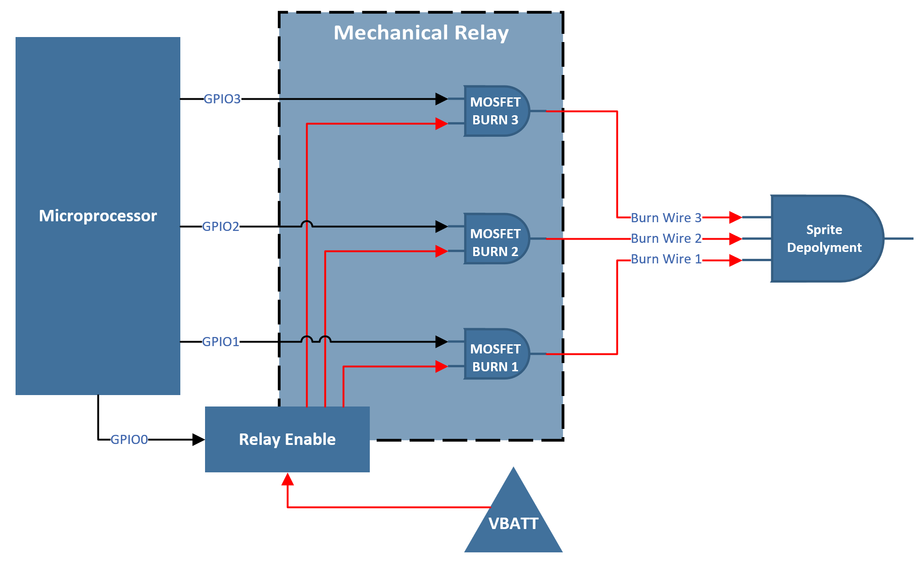

**References:**

K. Aaron et al., “Compendium of Recent Total Ionizing Dose Test Results Conducted by the Jet Propulsion Laboratory from 2003 through 2009,” *IEEE Radiation Effects Data Workshop*, 2009.

G. Allen, “Compendium of Test Results of Single Event Effects Conducted by the Jet Propulsion Laboratory,” *IEEE Radiation Effects Data Workshop*, 2008.

D. Cochran et al., “Total Ionizing Dose and Displacement Damage Compendium of Candidate Spacecraft Electronics for NASA,” *IEEE Radiation Effects Data Workshop*, 2009.

G. Allen et al., “Heavy Ion Induced Single-Event Latchup Screening of Integrated Circuits Using Commercial Off-the-Shelf Evaluation Boards,” *IEEE Radiation Effects Data Workshop*, 2016.

D. Cochran et al., “Compendium of Recent Total Ionizing Dose Results for Candidate Spacecraft Electronics for NASA,” *IEEE Radiation Effects Data Workshop*, 2008.

O’Bryan et al., “Compendium of Recent Single Event Effects Results for Candidate Spacecraft Electronics for NASA,” *IEEE Radiation Effects Data Workshop*, 2008.